Supplemental Primary Source Documents

Document C

Understands Farming, Shoemaking, and Fishing
(Transcription is modified for length and clarity.)
This “for sale” advertisement was printed in the Salem newspaper, “The Essex Gazette,” on November 20, 1770. The ad describes the labor of a 22-year-old man and a 27-year-old woman, both enslaved by Thomas Herrick of Beverly (next to Salem). Samuel Hall owned “The Essex Gazette” and was paid by Herrick to print this ad. Advertisements for “runaway” and “for sale” enslaved people were common and an important source of revenue for newspaper printers.

To be SOLD,
A stout, healthy Negro Man of 22 Years of Age, who understands Farming and Shoemaking, also the Fishing Business, which last he has followed these five Years past, and catches a good Share.
--Also, a Negro Woman of 27 Years of Age, who understands any Household Work. Any Persons that incline to purchase, for further particulars enquire of THOMAS HERRICK at Beverly.
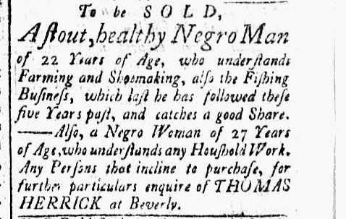

Document C
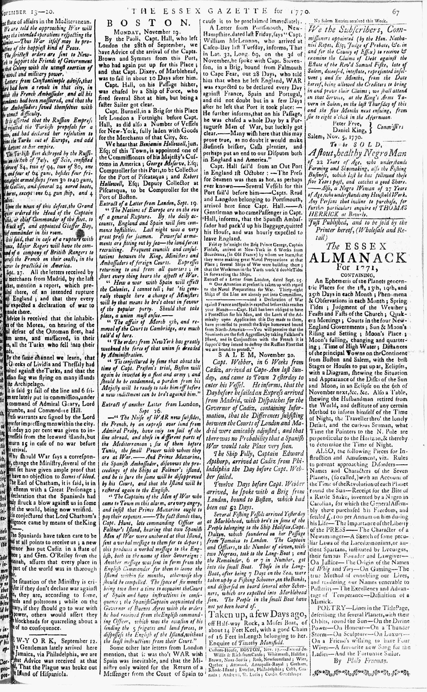

Image Source
The Essex Gazette, November 20, 1770. Vol. III, No. 121. Courtesy of Readex: America’s Historical Newspapers. Early American Newspapers, Series 1: From Colonies to Nation.

Document D

To the Selectman of the Town of Salem
(Transcription is modified for length and clarity.)
In the 18th and 19th centuries, enslaved and free Black people across New England participated in annual celebrations known as “Negro Election Day.” Some white people supported the holiday, while others did not. Nine Salem residents signed this petition in 1768, calling on the town government to “regulate” the celebration in Salem. Among them was Hasket Derby, son of Captain Richard Derby.

To the Selectmen of the Town of Salem
This Petition, from Inhabitants of said Town, humbly shows that as great disorder usually happens among us on Election Days, by Negroes assembling together, beating drums and
using powder to fire guns etc. etc. Some have appeared with swords and all which we think of bad tendency. We therefore pray that the town will obtain a bylaw to regulate those matters
or consider some other method to prevent for the future the appearances of such disorder in the town.
Salem, May 5, 1768
(Signed)
Peter Frye

Samuel Barton, Junior
Josjia Grant
George Crowninshield
(Elias) Hasket Derby
Jonathan Andrews
Thomas Mason
John Prince
Ebenezer Bickford

Vocabulary
- Selectmen: local government officials
- Powder: an explosive powder used to fire guns
- Bylaw: a rule or law
- Regulate: control or supervise something with rules and regulations

Document D

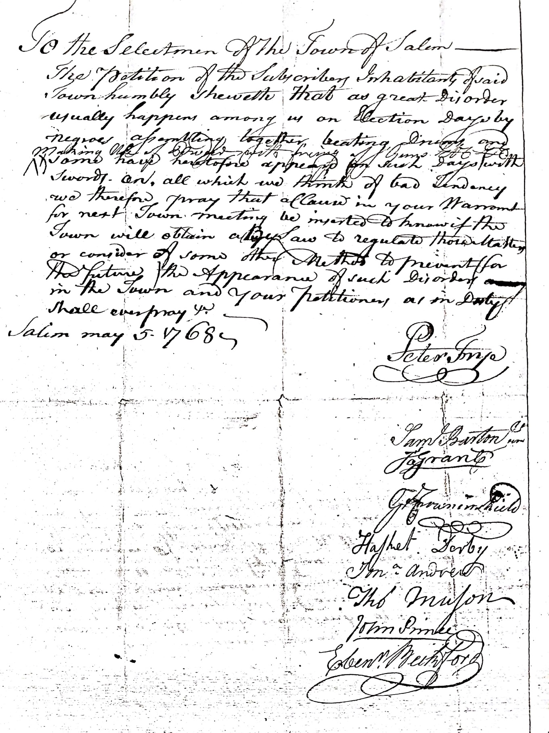

Image Source
Petition, Peter Frye, “Negroes Create Great Disorder” on Election Day, May 5, 1768. Courtesy of Salem State University Archives and Special Collections, City of Salem Archives Collection.

Document E

To Be Sold, A Likely Negro Girl, Twelve Years
(Transcription is modified for length and clarity.)
This “for sale” advertisement by an unknown colonist appeared in the “The Essex Gazette” July 7, 1772. Colonists interested in purchasing this enslaved child would seek information from the newspaper owner and printer, Samuel Hall of Salem. The advertisement was printed just below a “runaway” advertisement for an enslaved man named Cato.
To be sold,
A likeable negro girl, twelve-and-a-half-years-old, healthy, and strong, able to do all sorts of household work, particularly cooking. Can sew well on plain work and has been taught to read. Enquire of the Printers.

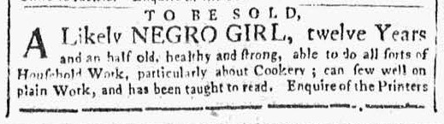

Image Source
The Essex Gazette, July 7, 1772. Vol. IV, No. 206. Courtesy of Readex: America’s Historical Newspapers. Early American Newspapers, Series 1: From Colonies to Nation.

Document E

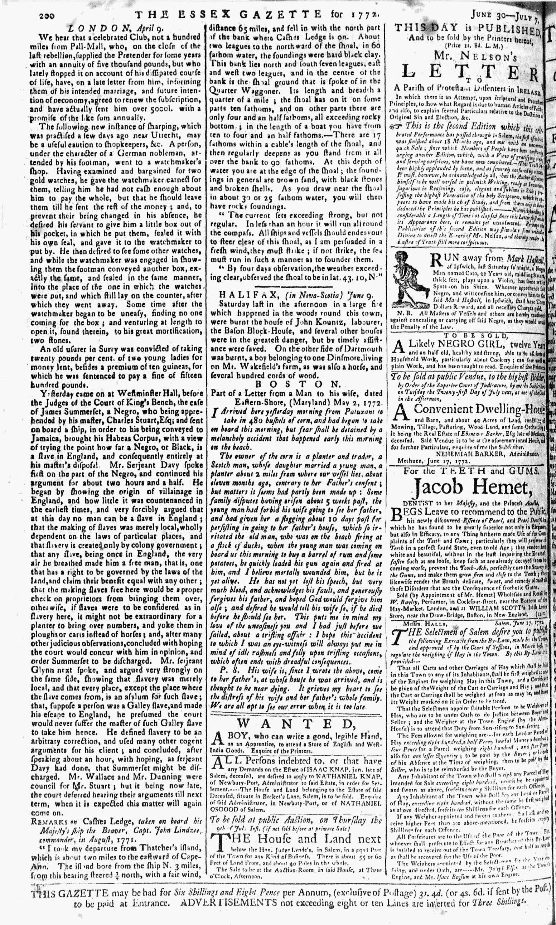

Image Source
The Essex Gazette, July 7, 1772. Vol. IV, No. 206. Courtesy of Readex: America’s Historical Newspapers. Early American Newspapers, Series 1: From Colonies to Nation.

